MMI 508 – THINK ALOUD REPORT

Ahmet Dara VEFA

2237899

First off, I want to start this report by asking if you need to access the project itself(to see the marks better etc.) let me know and I can share the project with your email(I think you can’t directly import/export the coded material).

I watched the video in alternative 2 and recorded the important bits and pieces to a txt file, entry by entry. This let me use the highlighting a bit better but was not really that necessary.

I also want to mention that I think I didn’t create good questions & guidelines because it feels like I should have made quite specific points that would make sense when combined with multiple documents from different people. Since I only had 1 person to “record” and observe combined with the fact my questions & guidelines were broad, the data I got from this study doesn’t feel like it has any value. If you think my questions were good or bad please let me know why and how to improve them.

I created 2 questions although neither of them were questions. First one is called “player requests/needs” which has 9 different guidelines (see appendix for screen shots). Second one is called “liked things” and since this was an inductive category I created guidelines on the go. But then again it feels like what I did was wrong.

So lets start with the first research question: “players requests/needs”. After reading through my transcription document I realized there were a lot of points written about how the player wants/needs something. After creating the question, I created my guidelines while reading through the transcription again. Then I entered coding part and started marking sentences one by one that fitted my guidelines. When I realized I needed to add another guideline I added it and continued. I also left some entries unmarked since they were not answering this question.

Now let’s continue with the second question: “liked things”. I created this question because the player mentioned a lot of things he liked and I though the developer team would like to know these to prevent any unwanted changes later on the development. I thought it would be enough to have 3 levels of abstraction(from small mention to big mention) and it truly was just enough for this transcription.

Overall, all the entries were marked by at least one question/guideline so I think I didn’t take unimportant notes except the one about the breakable looking rocks where I give details about why it could be. Since nothing marked the reason for looking breakable it won’t be included in the report; hence it was not required for me to note the reason of an entry.

This brings me to the end of my report. Having multiple documents would make a lot more sense for this assignment. It would also change the questions & guidelines because I could ask if players like the environment etc.

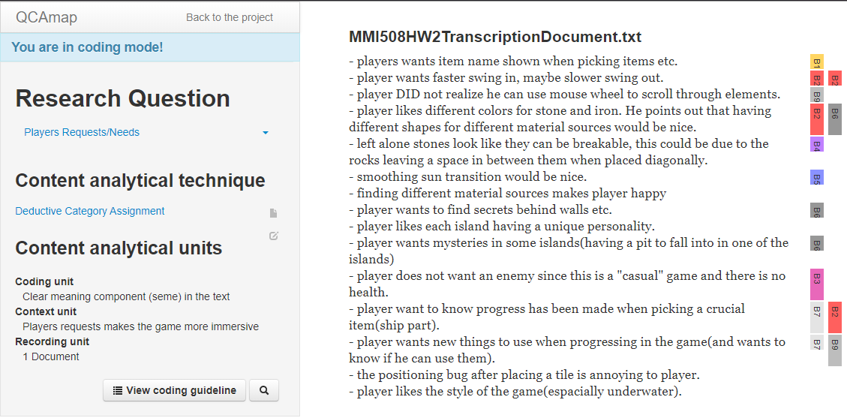

*“Players requests” question*

*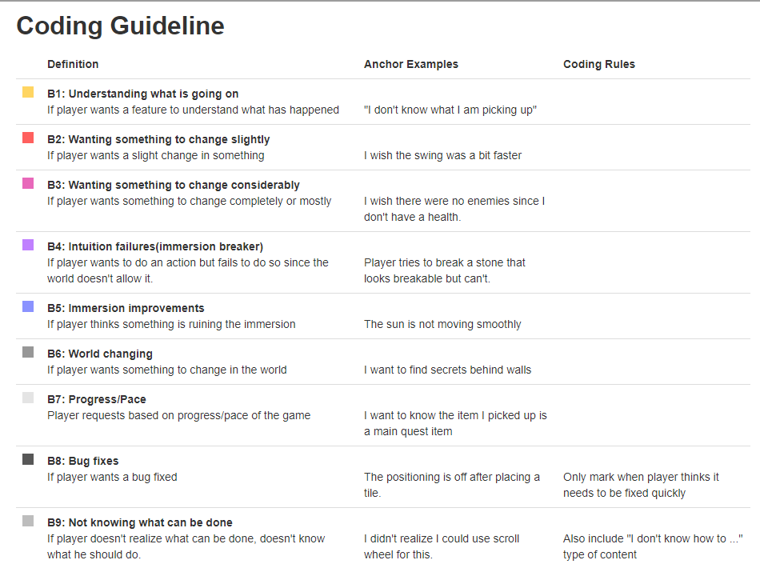*

*“Players requests” question guidelines*

*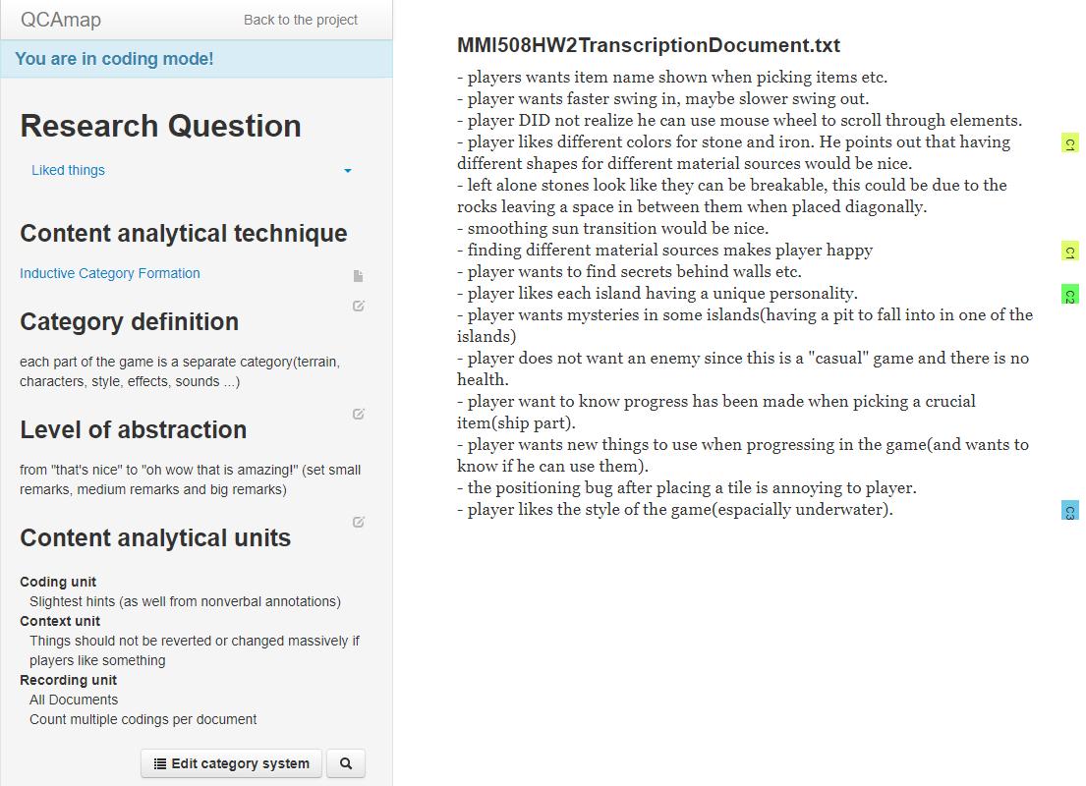*

*“Liked things” question*

*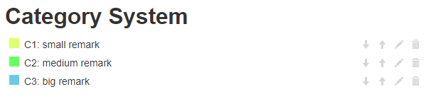*

*“Liked things” question categories*